The Friends of Southwark Park Membership Form
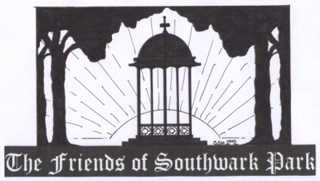

The Friends of Southwark Park Membership Form

The Friends of Southwark Park is an inclusive group that was formed to enable the community to get involved in the management of their park. It aims to promote, protect and enhance Southwark Park, King’s Stairs Gardens and King George’s Field. There is no membership fee.

___________________________________________________________________________
Membership Application (please print clearly)

Name……………………………………………………………………………………………

Address………………………………………………………………………………………..

…………………………………..………………………Postcode……………………………

Phone………………………………Email…………….………………………………………
___________________________________________________________________________

I would like to join The Friends of Southwark Park. I undertake to uphold the aims and objectives and to act in accordance with the principles laid out in The Friends of Southwark Park Constitution. I agree to my details being stored and used for FoSP business only.

Signature…………………………….………………………….........Date……….……………

Once completed and signed, please send this membership application form to the following address:

The Friends of Southwark Park, c/o 3, Westbrook Road, London, SE3 0NS

