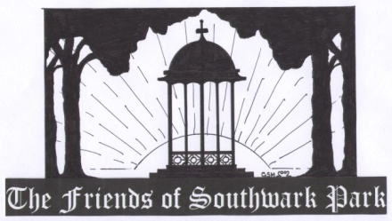

WHY NOT BECOME A MEMBER OF THE FRIENDS OF SOUTHWARK PARK?

The Friends of Southwark Park is an inclusive group that was formed to enable the community to get involved in the management of their park. We are open to all regardless of sex, age, disability, ethnicity, nationality, sexual orientation, religion or other beliefs. Currently there is no membership fee. We believe that the more members we have, the more our voice is heard. If you want to contribute to improving the park, complete our simple application form below.
Membership Application (please print clearly)

Name……………………………………………………………………………………………

Address………………………………………………………………………………………..

…………………………………..………………………Postcode……………………………

Phone………………………………Email…………….………………………………………

I would like to join The Friends of Southwark Park. I undertake to uphold the aims and objectives and to act in accordance with the principles laid out in The Friends of Southwark Park Constitution. I agree to my details being stored and used for FoSP business only.

Signature…………………………….………………………….........Date……….……………

Please send this membership application form to:

The Friends of Southwark Park, c/o 3, Fairoak Drive, London, SE9 2QG

