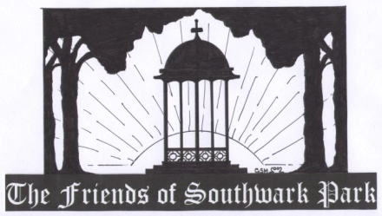

Patron: Simon Hughes M.P.
Chairperson: Gary Glover
Vice-Chairperson: Amanda Squires
Secretary: Pat Kingwell
Treasurer: Marjorie Hill
Assistant Treasurer: Ron Henocq
Membership: Corinne Turner

General Meeting
10th August 2011 6.00pm at
The Clubroom, Rear of St. Peters Church, 72 Paradise Street, SE16

Agenda

- Apologies

- Notes of meeting of 13th July 2011 and Matters Arising (attached)

- The Young Friends of Parks – Lindsay Gowlett Groundwork Southwark

- King’s Stairs Gardens Issues

- UK Power Networks Cable Tunnelling Works Proposals – Sharon Lomas LBS

- Former Nursery future use – Sharon Lomas LBS

- Thames Water Boreholes Proposals

- Park Manager’s Report – Andy Chatterton

- Photography Project Update – Pat Kingwell

- Bowling Club Update – Jim Saunders/ Colin Smith

- Finances - Marjorie Hill

- Membership Report – Corinne Turner

- Any Other Business

- Dates of Future Meetings

